**(1) Merger of Princely States**

(not for prelims this is important for mains.)

Post independence of India:

1. Merger of princely states.
2. Refugee issue.
3. Democracy and the first general election.
4. Linguistic issue
   1. National language
   2. Linguistic reorganization of state.
5. Tribal integration.
6. Land reforms.
7. Communalism.
8. National integration.

Merger of princely states:

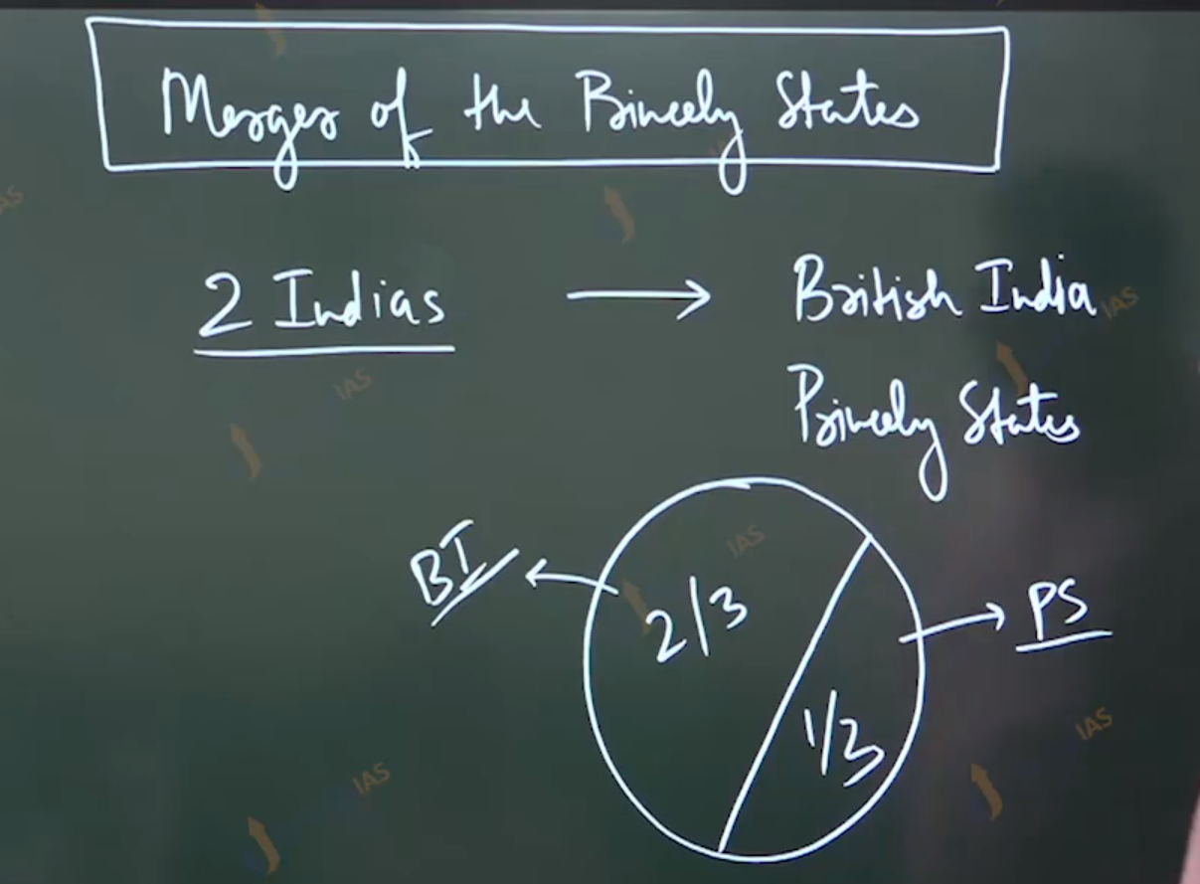

Since 1858:

1. Non annexation
2. Friendship
3. Co-operation
4. Defense

Reality